*UTS Praktikum Persamaan Model Struktural*

**UJIAN TENGAH SEMESTER**

disusun untuk memenuhi

tugas mata kuliah persamaan model struktural

Oleh:

**Kelompok 9**

**Al Haridt Mahmudi : 2008108010004**

**Fiqhi Desrian : 2008108010016**

**Gilang Awal Ramadhan : 2008108010097**



**JURUSAN STATISTIKA**

**FAKULTAS MATEMATIKA DAN ILMU PENGETAHUAN ALAM**

**UNIVERSITAS SYIAH KUALA**

**DARUSSALAM, BANDA ACEH**

**2022**

1. **Deskripsi Kasus dan Data**

Studi tentang pengaruh citra merek terhadap minat beli melalui sikap terhadap merek (kasus pada merek pasta gigi ciptadent di semarang) yang merupakan Tesis dari Bambang Pujadi, SE pada program Magister Manajemen Pascasarjana Universitas Diponegoro tahun 2010.

Data merupakan data primer yang dikumpulkan oleh Bambang Pujadi, SE melalui kuisoner yang telah dibuat dan memiliki 102 responden, dimana terdapat 17 pertanyaan untuk menganalisis faktor-faktor yang mempengaruhi citra merek sebagai upaya mempengaruhi sikap terhadap merek untuk peningkatan minat beli. Dari 17 variabel tersebut, dikelompokkan menjadi 5 variabel laten

Sumber: <http://eprints.undip.ac.id/24061/>

1. **Penyelesaian**
2. Tabel Variabel laten dan Variabel

|  |  |  |
| --- | --- | --- |
| **No.** | **Variabel Laten** | **Variabel Indikator** |
| 1 | Persepsi Kualitas | PK1 = Kemampuan Inti |
| PK2 = Fitur |
| PK3 = Kualitas Kesesuaian |
| 2 | Kualitas Pesan lklan | KP1 = Pesan dipahami |
| KP2 = lklan diingat |
| KP3 = lklan memberikan informasi yang dapat dipercaya |
| KP4 = lklan memberikan informasi yang jelas |
| 3 | Citra Merek | CM1 = Kesan profesional |
| CM2 = Kesan Modern |
| CM3 = Melayani semua segmen |
| CM4 = Perhatian pada konsumen |
| 4 | Sikap terhadap Merek | SM1 = Merek diingat |
| SM2 = Merek disukai |
| SM3 = Merek dipilih |
| 5 | Minat Bell | MB1 = Mencari informasi tentang tempat pembelian |
| MB2 = Mencari informasi tentang harga |
| MB3 = Keinginan segera membeli |

***Tabel 2.1.*** *Deskripsi setiap Variabel*

1. **Model Pengukuran Struktural**

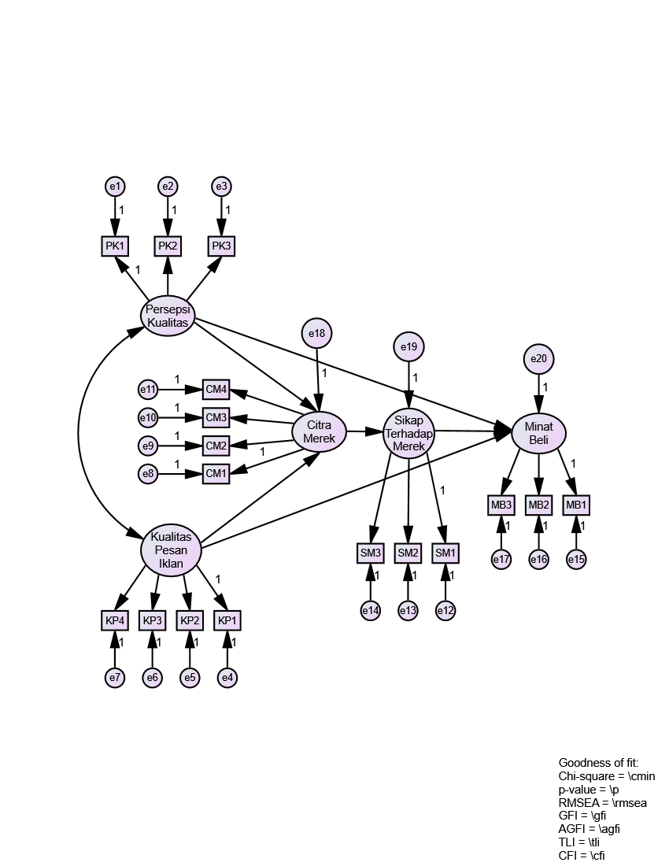

**Model Pengukuran**

**Model Pengukuran**

**Model Pengukuran**

**Model Pengukuran**

**Model Pengukuran**

**Model Struktural**

***Gambar 3.1*** *Model Strukturan dan Pengukuran*

1. **Model Setelah Calculate estimate**

***Gambar 4.1*** *Model Setelah Calculate estimate*

1. **Uji Asumsi**
2. **Normalitas**

***Gambar 5.1*** *Normalitas*

Dengan menggunakan kriteria critical ratio sebesar 2,58 maka melalui pengamatan angka‐angka pada kolom C.R yang ditunjukkan pada tabel diatas dapat disimpulkan tidak ada angka yang lebih besar dari 2,58. Hal tersebut memberikan bukti bahwa data yang digunakan mempunyai sebaran yang normal.

1. **Outlier**

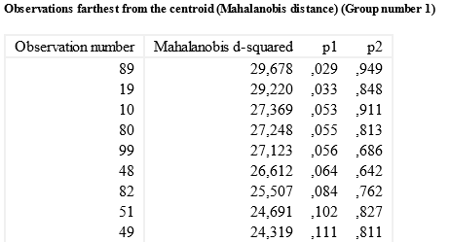

**……………………………………………………………………………**

***Gambar 5.2*** *Outlier*

Ada atau tidaknya outlier multivariat dapat dilihat dari jarak mahalanobis (Mahalanobis distance). Uji mahalanobis dapat dilakukan dengan perhitungan jarak Mahalanobis melalui program Amos 16. Dari pengolahan data yang telah dilakukan, diperoleh hasil bahwa jarak Mahalanobis minimum adalah 7,926 dan maksimum adalah 29,678. Berdasarkan nilai chi‐square yaitu 40,790 dengan derajat bebas 17 (jumlah indikator) pada tingkat signifikansi 0,001 tidak terdapat atau tidak terjadi outlier karena nilai Mahalanobis distance data tidak ada yang melebihi 40,790.

1. **Uji Kesesuaian Model**

|  |  |  |  |
| --- | --- | --- | --- |
| Goodness of Fit Index | Cut‐off Value | Hasil Olah Data | Evaluasi model |
| Chi‐Square | $$< 137,70$$ | 122,545 | Baik |
| P-value | $$≥0,05$$ | 0,233 | Baik |
| RMSEA | $$≤0,08$$ | 0,031 | Baik |
| GFI | $$0,90 ≤GFI≤ 1,0$$ | 0,888 | Marginal |
| AGFI | $$0,90 ≤AGFI≤ 1,0$$ | 0,848 | Marginal |
| TLI | $$0,95 ≤TLI ≤1,0$$ | 0,986 | Baik |
| CFI | $$0,95 ≤CFI≤1,0$$ | 0,989 | Baik |

***Tabel 6.1*** *Tabel Goodness of Fit Index*

Dari output ini dapat dilihat bahwa Chi-square dikatakan baik karena 122.545 < 137.70, p-value baik karena 0.233 > 0.05, RMSEA baik karena 0.031 < 0.08, GFI marginal karena 0.90 < 0.888 < 1.0, marginal karena 0.90 < 0.848 < 1.0, TLI baik karena 0.95 < 0.986 < 1.0 dan CFI baik karena 0.95 < 0.989 < 1.0. Maka dengan demikian berarti konstruk‐konstruk yang digunakan untuk membentuk sebuah model penelitian telah memenuhi kriteria kelayakan sebuah model.

1. **Lampiran**
2. **Data**

|  |  |  |  |  |  |  |  |  |  |  |  |  |  |  |  |  |  |
| --- | --- | --- | --- | --- | --- | --- | --- | --- | --- | --- | --- | --- | --- | --- | --- | --- | --- |
| **No** | **PK1** | **PK2** | **PK3** | **KP1** | **KP2** | **KP3** | **KP4** | **CM1** | **CM2** | **CM3** | **CM4** | **SM1** | **SM2** | **SM3** | **MB1** | **MB2** | **MB3** |
| 1 | 7 | 6 | 7 | 6 | 4 | 5 | 7 | 6 | 5 | 5 | 6 | 7 | 8 | 6 | 6 | 8 | 7 |
| 2 | 4 | 5 | 6 | 6 | 6 | 5 | 5 | 5 | 4 | 5 | 6 | 4 | 5 | 4 | 5 | 5 | 5 |
| 3 | 10 | 8 | 9 | 7 | 7 | 8 | 5 | 7 | 6 | 7 | 8 | 6 | 6 | 9 | 10 | 9 | 8 |
| 4 | 7 | 5 | 6 | 6 | 6 | 4 | 5 | 6 | 5 | 6 | 6 | 8 | 8 | 8 | 6 | 5 | 4 |
| 5 | 8 | 8 | 9 | 7 | 5 | 6 | 7 | 8 | 8 | 10 | 9 | 8 | 6 | 8 | 7 | 8 | 7 |
| 6 | 6 | 7 | 7 | 9 | 9 | 9 | 8 | 7 | 8 | 8 | 9 | 6 | 8 | 8 | 8 | 7 | 7 |
| 7 | 6 | 6 | 7 | 7 | 9 | 8 | 6 | 5 | 6 | 6 | 6 | 9 | 7 | 8 | 6 | 8 | 8 |
| 8 | 6 | 7 | 7 | 8 | 7 | 8 | 8 | 6 | 8 | 7 | 8 | 8 | 6 | 7 | 8 | 9 | 7 |
| 9 | 5 | 4 | 6 | 5 | 8 | 10 | 6 | 7 | 7 | 5 | 7 | 5 | 5 | 6 | 5 | 7 | 7 |
| 10 | 5 | 6 | 6 | 6 | 4 | 7 | 5 | 7 | 8 | 6 | 5 | 7 | 6 | 7 | 4 | 4 | 3 |
| 11 | 5 | 6 | 6 | 5 | 4 | 7 | 6 | 6 | 7 | 7 | 7 | 8 | 7 | 5 | 4 | 3 | 3 |
| 12 | 4 | 5 | 6 | 6 | 5 | 6 | 6 | 5 | 6 | 6 | 6 | 7 | 8 | 7 | 6 | 9 | 8 |
| 13 | 9 | 10 | 8 | 8 | 8 | 8 | 7 | 8 | 9 | 8 | 8 | 10 | 9 | 9 | 10 | 9 | 9 |
| 14 | 7 | 7 | 8 | 6 | 6 | 7 | 7 | 4 | 5 | 6 | 5 | 8 | 7 | 6 | 9 | 7 | 9 |
| 15 | 5 | 6 | 7 | 6 | 7 | 7 | 6 | 6 | 7 | 8 | 6 | 7 | 7 | 6 | 7 | 9 | 9 |
| 16 | 7 | 8 | 9 | 6 | 8 | 7 | 6 | 8 | 9 | 7 | 7 | 7 | 6 | 6 | 7 | 6 | 7 |
| 17 | 4 | 6 | 6 | 8 | 7 | 4 | 7 | 6 | 5 | 5 | 6 | 4 | 5 | 3 | 4 | 2 | 3 |
| 18 | 4 | 6 | 5 | 8 | 8 | 8 | 9 | 7 | 6 | 6 | 8 | 5 | 6 | 4 | 6 | 5 | 4 |
| 19 | 4 | 6 | 5 | 8 | 8 | 3 | 8 | 8 | 6 | 7 | 6 | 8 | 6 | 5 | 6 | 5 | 6 |
| 20 | 7 | 9 | 8 | 9 | 9 | 10 | 8 | 9 | 8 | 8 | 6 | 6 | 8 | 8 | 9 | 8 | 8 |
| 21 | 8 | 9 | 8 | 7 | 10 | 9 | 8 | 8 | 9 | 8 | 8 | 9 | 7 | 9 | 8 | 8 | 8 |
| 22 | 7 | 7 | 9 | 10 | 8 | 9 | 8 | 7 | 8 | 7 | 6 | 6 | 8 | 7 | 8 | 7 | 8 |
| 23 | 5 | 5 | 6 | 8 | 8 | 9 | 9 | 8 | 9 | 8 | 8 | 6 | 7 | 6 | 6 | 5 | 7 |
| 24 | 6 | 6 | 7 | 6 | 6 | 6 | 6 | 5 | 6 | 4 | 4 | 5 | 6 | 5 | 9 | 9 | 9 |
| 25 | 4 | 6 | 5 | 5 | 4 | 4 | 4 | 3 | 5 | 5 | 5 | 7 | 8 | 6 | 7 | 4 | 5 |
| 26 | 7 | 6 | 5 | 5 | 5 | 5 | 5 | 7 | 6 | 7 | 5 | 8 | 7 | 5 | 6 | 5 | 8 |
| 27 | 9 | 8 | 9 | 6 | 8 | 7 | 6 | 6 | 8 | 8 | 9 | 9 | 6 | 7 | 9 | 8 | 8 |
| 28 | 8 | 9 | 9 | 7 | 8 | 6 | 7 | 5 | 6 | 4 | 4 | 4 | 3 | 7 | 8 | 7 | 8 |
| 29 | 7 | 5 | 6 | 8 | 7 | 8 | 7 | 10 | 9 | 7 | 8 | 8 | 7 | 8 | 7 | 6 | 7 |
| 30 | 7 | 8 | 7 | 9 | 9 | 10 | 9 | 9 | 10 | 8 | 9 | 7 | 9 | 8 | 7 | 9 | 9 |
| 31 | 9 | 8 | 9 | 5 | 7 | 8 | 8 | 9 | 8 | 8 | 8 | 10 | 9 | 6 | 7 | 8 | 9 |
| 32 | 8 | 9 | 8 | 8 | 8 | 7 | 9 | 7 | 5 | 6 | 5 | 7 | 9 | 7 | 6 | 5 | 7 |
| 33 | 6 | 4 | 5 | 8 | 8 | 7 | 7 | 6 | 5 | 6 | 6 | 7 | 7 | 5 | 4 | 5 | 4 |
| 34 | 5 | 6 | 5 | 6 | 6 | 5 | 6 | 7 | 8 | 6 | 6 | 6 | 5 | 5 | 7 | 6 | 5 |
| 35 | 8 | 7 | 8 | 7 | 6 | 8 | 8 | 8 | 9 | 7 | 8 | 7 | 6 | 8 | 7 | 8 | 7 |
| 36 | 9 | 8 | 7 | 8 | 7 | 7 | 7 | 8 | 10 | 8 | 10 | 8 | 9 | 8 | 10 | 8 | 9 |
| 37 | 10 | 10 | 9 | 8 | 7 | 8 | 8 | 7 | 8 | 8 | 8 | 7 | 8 | 7 | 7 | 8 | 6 |
| 38 | 6 | 6 | 6 | 8 | 8 | 8 | 8 | 7 | 7 | 10 | 6 | 9 | 9 | 7 | 8 | 8 | 6 |
| 39 | 7 | 7 | 6 | 5 | 7 | 7 | 6 | 7 | 8 | 8 | 9 | 7 | 6 | 7 | 5 | 6 | 6 |
| 40 | 8 | 9 | 7 | 5 | 5 | 4 | 6 | 5 | 6 | 6 | 5 | 6 | 6 | 8 | 8 | 9 | 7 |
| 41 | 5 | 7 | 6 | 3 | 5 | 4 | 4 | 6 | 5 | 6 | 6 | 6 | 5 | 4 | 5 | 5 | 5 |
| 42 | 7 | 5 | 6 | 7 | 8 | 8 | 9 | 5 | 7 | 7 | 7 | 6 | 6 | 8 | 6 | 7 | 6 |
| 43 | 5 | 5 | 5 | 6 | 9 | 10 | 8 | 9 | 10 | 8 | 10 | 5 | 7 | 7 | 6 | 5 | 5 |
| 44 | 6 | 6 | 8 | 5 | 5 | 4 | 4 | 5 | 5 | 6 | 6 | 7 | 6 | 7 | 6 | 7 | 5 |
| 45 | 7 | 9 | 8 | 6 | 5 | 6 | 6 | 6 | 5 | 7 | 6 | 7 | 8 | 7 | 8 | 7 | 9 |
| 46 | 9 | 8 | 9 | 6 | 7 | 8 | 8 | 9 | 10 | 9 | 9 | 10 | 9 | 7 | 8 | 8 | 7 |
| 47 | 5 | 7 | 6 | 8 | 7 | 10 | 10 | 7 | 8 | 8 | 8 | 7 | 7 | 6 | 9 | 7 | 7 |
| 48 | 7 | 8 | 7 | 5 | 7 | 6 | 6 | 8 | 7 | 9 | 8 | 10 | 9 | 10 | 4 | 6 | 8 |
| 49 | 5 | 7 | 6 | 5 | 4 | 3 | 3 | 6 | 5 | 4 | 5 | 2 | 6 | 7 | 6 | 5 | 4 |
| 50 | 6 | 7 | 8 | 6 | 6 | 5 | 5 | 5 | 6 | 7 | 7 | 5 | 6 | 5 | 6 | 5 | 5 |
| 51 | 8 | 7 | 6 | 7 | 6 | 8 | 8 | 10 | 8 | 7 | 5 | 7 | 7 | 6 | 7 | 7 | 8 |
| 52 | 6 | 7 | 6 | 4 | 4 | 4 | 5 | 6 | 7 | 7 | 7 | 8 | 8 | 8 | 6 | 7 | 5 |
| 53 | 7 | 5 | 6 | 7 | 6 | 7 | 7 | 6 | 7 | 5 | 6 | 7 | 6 | 7 | 7 | 6 | 8 |
| 54 | 6 | 7 | 7 | 4 | 7 | 5 | 6 | 7 | 8 | 6 | 6 | 7 | 6 | 9 | 8 | 6 | 7 |
| 55 | 7 | 8 | 7 | 7 | 6 | 7 | 7 | 6 | 5 | 5 | 6 | 7 | 6 | 6 | 9 | 8 | 9 |
| 56 | 4 | 7 | 6 | 6 | 5 | 6 | 6 | 5 | 5 | 7 | 5 | 6 | 8 | 6 | 5 | 8 | 7 |
| 57 | 7 | 6 | 6 | 4 | 5 | 5 | 5 | 6 | 7 | 7 | 6 | 6 | 6 | 6 | 10 | 6 | 8 |
| 58 | 6 | 7 | 7 | 4 | 6 | 6 | 5 | 5 | 6 | 6 | 6 | 2 | 2 | 3 | 4 | 3 | 4 |
| 59 | 8 | 7 | 9 | 10 | 9 | 9 | 8 | 8 | 9 | 9 | 8 | 8 | 7 | 7 | 9 | 10 | 10 |
| 60 | 8 | 7 | 8 | 6 | 7 | 7 | 7 | 7 | 6 | 8 | 5 | 7 | 6 | 8 | 8 | 7 | 8 |
| 61 | 7 | 7 | 9 | 9 | 8 | 10 | 9 | 9 | 8 | 8 | 9 | 7 | 8 | 10 | 9 | 9 | 8 |
| 62 | 7 | 8 | 7 | 9 | 10 | 10 | 9 | 8 | 9 | 10 | 8 | 9 | 10 | 7 | 10 | 9 | 10 |
| 63 | 7 | 6 | 8 | 6 | 7 | 6 | 5 | 5 | 7 | 7 | 7 | 5 | 6 | 4 | 6 | 5 | 8 |
| 64 | 4 | 5 | 6 | 6 | 7 | 3 | 5 | 7 | 6 | 5 | 5 | 6 | 7 | 6 | 5 | 6 | 4 |
| 65 | 9 | 10 | 8 | 9 | 8 | 8 | 9 | 9 | 9 | 7 | 9 | 7 | 6 | 8 | 7 | 9 | 7 |
| 66 | 6 | 6 | 7 | 6 | 8 | 6 | 7 | 8 | 7 | 7 | 7 | 5 | 7 | 8 | 7 | 6 | 7 |
| 67 | 7 | 7 | 8 | 10 | 9 | 8 | 8 | 9 | 8 | 10 | 9 | 10 | 9 | 9 | 10 | 9 | 8 |
| 68 | 4 | 5 | 5 | 6 | 8 | 7 | 7 | 5 | 6 | 6 | 6 | 5 | 5 | 6 | 4 | 5 | 6 |
| 69 | 9 | 8 | 9 | 6 | 6 | 5 | 6 | 8 | 9 | 9 | 8 | 8 | 8 | 8 | 7 | 8 | 9 |
| 70 | 5 | 4 | 6 | 6 | 5 | 4 | 5 | 5 | 6 | 6 | 5 | 7 | 8 | 6 | 7 | 8 | 5 |
| 71 | 5 | 6 | 6 | 7 | 8 | 6 | 6 | 5 | 5 | 5 | 5 | 6 | 6 | 6 | 5 | 6 | 6 |
| 72 | 6 | 5 | 5 | 7 | 5 | 9 | 7 | 6 | 5 | 7 | 5 | 7 | 7 | 7 | 8 | 6 | 5 |
| 73 | 6 | 7 | 7 | 7 | 6 | 9 | 8 | 10 | 10 | 10 | 9 | 9 | 8 | 8 | 9 | 10 | 6 |
| 74 | 6 | 4 | 5 | 4 | 5 | 4 | 4 | 5 | 6 | 8 | 6 | 7 | 6 | 7 | 6 | 6 | 4 |
| 75 | 7 | 7 | 7 | 8 | 9 | 10 | 8 | 9 | 8 | 8 | 7 | 7 | 8 | 7 | 8 | 7 | 7 |
| 76 | 5 | 6 | 5 | 9 | 9 | 9 | 8 | 7 | 8 | 8 | 8 | 7 | 9 | 7 | 8 | 9 | 8 |
| 77 | 10 | 9 | 9 | 8 | 7 | 8 | 8 | 9 | 10 | 8 | 7 | 9 | 7 | 8 | 9 | 10 | 7 |
| 78 | 7 | 8 | 7 | 7 | 7 | 5 | 6 | 6 | 6 | 7 | 6 | 7 | 4 | 5 | 8 | 8 | 6 |
| 79 | 9 | 7 | 8 | 4 | 5 | 4 | 4 | 7 | 8 | 9 | 8 | 8 | 9 | 7 | 6 | 5 | 7 |
| 80 | 4 | 4 | 5 | 5 | 2 | 3 | 5 | 6 | 7 | 7 | 8 | 5 | 4 | 4 | 7 | 5 | 4 |
| 81 | 6 | 4 | 5 | 7 | 7 | 6 | 8 | 4 | 5 | 7 | 5 | 6 | 5 | 5 | 5 | 7 | 6 |
| 82 | 4 | 4 | 5 | 4 | 4 | 6 | 8 | 6 | 5 | 6 | 6 | 9 | 8 | 8 | 5 | 8 | 5 |
| 83 | 8 | 9 | 10 | 9 | 9 | 8 | 7 | 9 | 9 | 10 | 6 | 8 | 9 | 9 | 10 | 8 | 8 |
| 84 | 7 | 8 | 9 | 7 | 6 | 9 | 7 | 9 | 8 | 10 | 7 | 9 | 8 | 9 | 8 | 7 | 8 |
| 85 | 3 | 5 | 5 | 6 | 5 | 5 | 7 | 7 | 8 | 6 | 5 | 7 | 8 | 7 | 8 | 6 | 7 |
| 86 | 7 | 6 | 7 | 7 | 7 | 6 | 6 | 5 | 6 | 5 | 7 | 4 | 3 | 4 | 4 | 6 | 5 |
| 87 | 7 | 8 | 9 | 5 | 6 | 5 | 8 | 8 | 9 | 8 | 7 | 9 | 10 | 7 | 6 | 7 | 8 |
| 88 | 4 | 5 | 4 | 7 | 6 | 4 | 7 | 6 | 5 | 7 | 4 | 6 | 7 | 6 | 6 | 5 | 4 |
| 89 | 7 | 8 | 7 | 8 | 5 | 7 | 7 | 4 | 6 | 3 | 6 | 6 | 7 | 8 | 5 | 6 | 7 |
| 90 | 9 | 7 | 8 | 8 | 9 | 9 | 8 | 7 | 6 | 6 | 6 | 6 | 7 | 6 | 9 | 10 | 7 |
| 91 | 4 | 5 | 5 | 7 | 7 | 6 | 6 | 5 | 7 | 6 | 7 | 7 | 6 | 5 | 5 | 7 | 4 |
| 92 | 6 | 8 | 7 | 8 | 8 | 8 | 6 | 9 | 9 | 9 | 7 | 10 | 10 | 10 | 10 | 9 | 9 |
| 93 | 6 | 5 | 5 | 6 | 7 | 8 | 7 | 9 | 7 | 7 | 9 | 8 | 7 | 7 | 6 | 7 | 6 |
| 94 | 7 | 7 | 8 | 7 | 5 | 5 | 8 | 8 | 8 | 8 | 7 | 5 | 6 | 7 | 6 | 7 | 6 |
| 95 | 9 | 10 | 9 | 7 | 7 | 6 | 8 | 6 | 7 | 5 | 8 | 5 | 6 | 7 | 7 | 8 | 6 |
| 96 | 4 | 5 | 4 | 7 | 6 | 4 | 4 | 7 | 7 | 6 | 6 | 7 | 6 | 7 | 6 | 7 | 6 |
| 97 | 4 | 5 | 4 | 5 | 7 | 8 | 3 | 7 | 6 | 5 | 6 | 6 | 7 | 7 | 6 | 7 | 5 |
| 98 | 6 | 7 | 6 | 9 | 8 | 7 | 4 | 5 | 6 | 6 | 8 | 4 | 7 | 6 | 8 | 6 | 5 |
| 99 | 8 | 9 | 8 | 6 | 8 | 8 | 7 | 7 | 5 | 7 | 7 | 7 | 2 | 6 | 7 | 8 | 8 |
| 100 | 8 | 9 | 8 | 5 | 5 | 5 | 4 | 6 | 7 | 5 | 5 | 6 | 4 | 7 | 8 | 6 | 6 |
| 101 | 5 | 4 | 4 | 9 | 9 | 7 | 7 | 8 | 10 | 7 | 7 | 8 | 9 | 7 | 8 | 8 | 7 |
| 102 | 6 | 6 | 7 | 8 | 8 | 8 | 5 | 8 | 9 | 7 | 8 | 9 | 6 | 8 | 8 | 8 | 8 |

***Tabel 7.1*** *Data*

1. **Model dan Goodness of Fit**

***Gambar 7.1*** *Model dan Goodness of Fit*